SIF-AU Assessment Objects, October Draft

Contents

1. Gradebook assessment 2

1.1. Conceptual Model: 3

1.2. Logical Model 5

1.3. Workflows 5

Formative Assessment within school: 5

Formative Assessment within school, remedial use: 6

Formative Assessment within school, multiple drafts: 7

Subject Assessment within school, grade: 7

Reporting of Assessment: 7

Student Transfer: 8

2. Qualifications/Credentials/Achievement/Attainment 8

2.1. Conceptual Model 9

2.2. Logical Model 13

StudentAttainmentAchievement 17

2.3. Workflows 21

Enrolment in class: 21

Enrolment in assessment: 21

Enrolment in course: 22

Enrolment for Credential: 23

Student transfer with aim to continue work on Credential: 24

Student transfer, Transcript used for Recognition of Prior Learning: 25

3. Appendix 25

3.1. Appendix: CredentialDetails Prototype 25

3.2. PESC prior art 28

4. Draft Realisation of Gradebook assessment 29

Realisation of Types 38

38

The 2016 and 2017 assessment workshops conducted by NSIP have identified three sets of objects relevant to assessment, that should be encoded in SIF-AU:

* **Gradebook assessment** objects, intended for primary school assessment and secondary formative assessment, and including end of term grades.
* **Summative assessment** objects, intended for secondary school assessment, and capturing complex, externally assessed assessments.
* **Credentials**, intended for secondary school assessment, and presenting achievements of students which form part of their student transcript.

The 2017 workshop in particular highlighted the need for assessment objects to be provided at varying levels of granularity, according to the needs of the consumer. Object design reflects that need by:

* Making many of the characteristics specifying details of assessment optional;
* Permitting more detailed information to be provided through recursive links (an assignment may optionally consist of more detail sub-assignments; a score may optionally consist of sub-scores)
* Allowing parties to negotiate mutual knowledge in advance of the actual data exchange, if the parties come from different contexts (e.g. explicit details on marks, learning standards, markers). If the parties have shared context around the assessment, providing that level of detail should be unnecessary.

The SIF-AU standard up until SIF 1.4 included objects which addressed external summative assessment at a high level of sophistication, taken from the SIF-US data model. Those objects had not seen any usage in Australia, and did not respond to the more immediate need for gradebook assessment; they were withdrawn until local requirements could be established. In the interim, a custom set of objects was generated specific to NAPLAN Online, as the most broadly visible external summative assessment in Australia.

Analysis of local requirements for external summative assessment is ongoing, and involves discussion with New Zealand, which requires modelling for such assessment more urgently than Australia. In this release, we are presenting proposals for the other two areas identified: Gradebook/Formative assessment, and Credentials.

# Gradebook assessment

The SIF-AU data model currently incorporates two objects for gradebook assessment:

* GradingAssignment, representing both the assignment event and assignment form for generic or formative assessment
* GradingAssignmentScore, representing a generic assignment result or the result received by a student for formative assessment

The data model has been enhanced to add the following objects:

* StudentGrade (re-factored from SIF-US Gradebook objects), representing the overall grade received for a subject by a student. Relative to the SIF-US object, the StudentGrade includes:
  + provision for an overall teacher judgement
  + optionally links to the staff member marking the student and providing the teacher judgement
  + the learning area for the subject graded
  + optional links to one or more GradingAssignmentScore objects, the scores of which have contributed to this grade
* MarkValueInfo (re-factored from SIF-US Gradebook objects), representing the interpretation of a StudentGrade mark or a GradingAssignmentScore mark for external consumers.
  + Relative to the SIF-US object, the MarkValueInfo object has been flattened, and it includes information on whether the given mark represents a passing grade.

The objects have been enhanced to address requirements captured in the workshops, as follows:

* GradingAssignment can be composed of other GradingAssignment objects recursively. This allows assignments to be described at a more granular level as required. GradingAssignment can potentially be used to describe a subtest or individual questions within the assessment.
* GradingAssignment has added attributes to convey the purpose of the assessment, and the level at which it is assessed.
* GradingAssignment optionally includes rubrics, providing scoring guides for marking the assignment.
* GradingAssignment optionally includes prerequisite conditions to be met, for the student to be eligible to undertake the assignment. Prerequisites can include attendance, other assessments, and recognition of prior learning.
* GradingAssignment optionally includes learning standards, indicating competencies or standards that the assignment assesses the student against. These learning standards may be part of a formal hierarchical curriculum, as already expressed in SIF-AU through LearningStandardItem; they may also be more informally expressed as hyperlinks or descriptive text, without necessarily belonging to a formal curriculum. (For example, they may be part of a local curriculum, or a student’s individual learning plan.)
* GradingAssignmentScore can be used to convey an expected score for a student, rather than the score they actually received. This is useful in case a student has not provided a response to the assessment, but will still receive a default score for the assessment rather than a zero score.
* GradingAssignmentScore includes a date for when the assignment was marked.
* GradingAssignmentScore includes an indication of the iteration of an assignment submission that it is scoring. This permits a student to submit an assignment for marking multiple times.
* GradingAssignmentScore includes an optional link to the teacher who has marked the assignment.
* GradingAssignmentScore optionally includes a teacher judgement.
* GradingAssignmentScore optionally includes the original script being marked.
* GradingAssignmentScore optionally includes subscores corresponding to each of the rubrics in the assignment.
* GradingAssignmentScore optionally links to WellbeingCharacteristic, which may provide special circumstances for the student as context to interpreting their score.
* GradingAssignmentScore optionally links to a MarkValueInfo object, which provides context for interpreting the mark received.

## Conceptual Model:



(Red objects are additions reflecting the 2017 workshop.)

* Note: Class refers to a group of students meeting for instructional purposes, and is equivalent to the SIF-US Section object. The corresponding SIF-AU TeachingGroup is denormalised, as it also contains references to students, staff, rooms and periods.
* Note: the arrows on this diagram do not imply that all links are mandatory. A Grading Assignment for example may not be assigned to a Class.

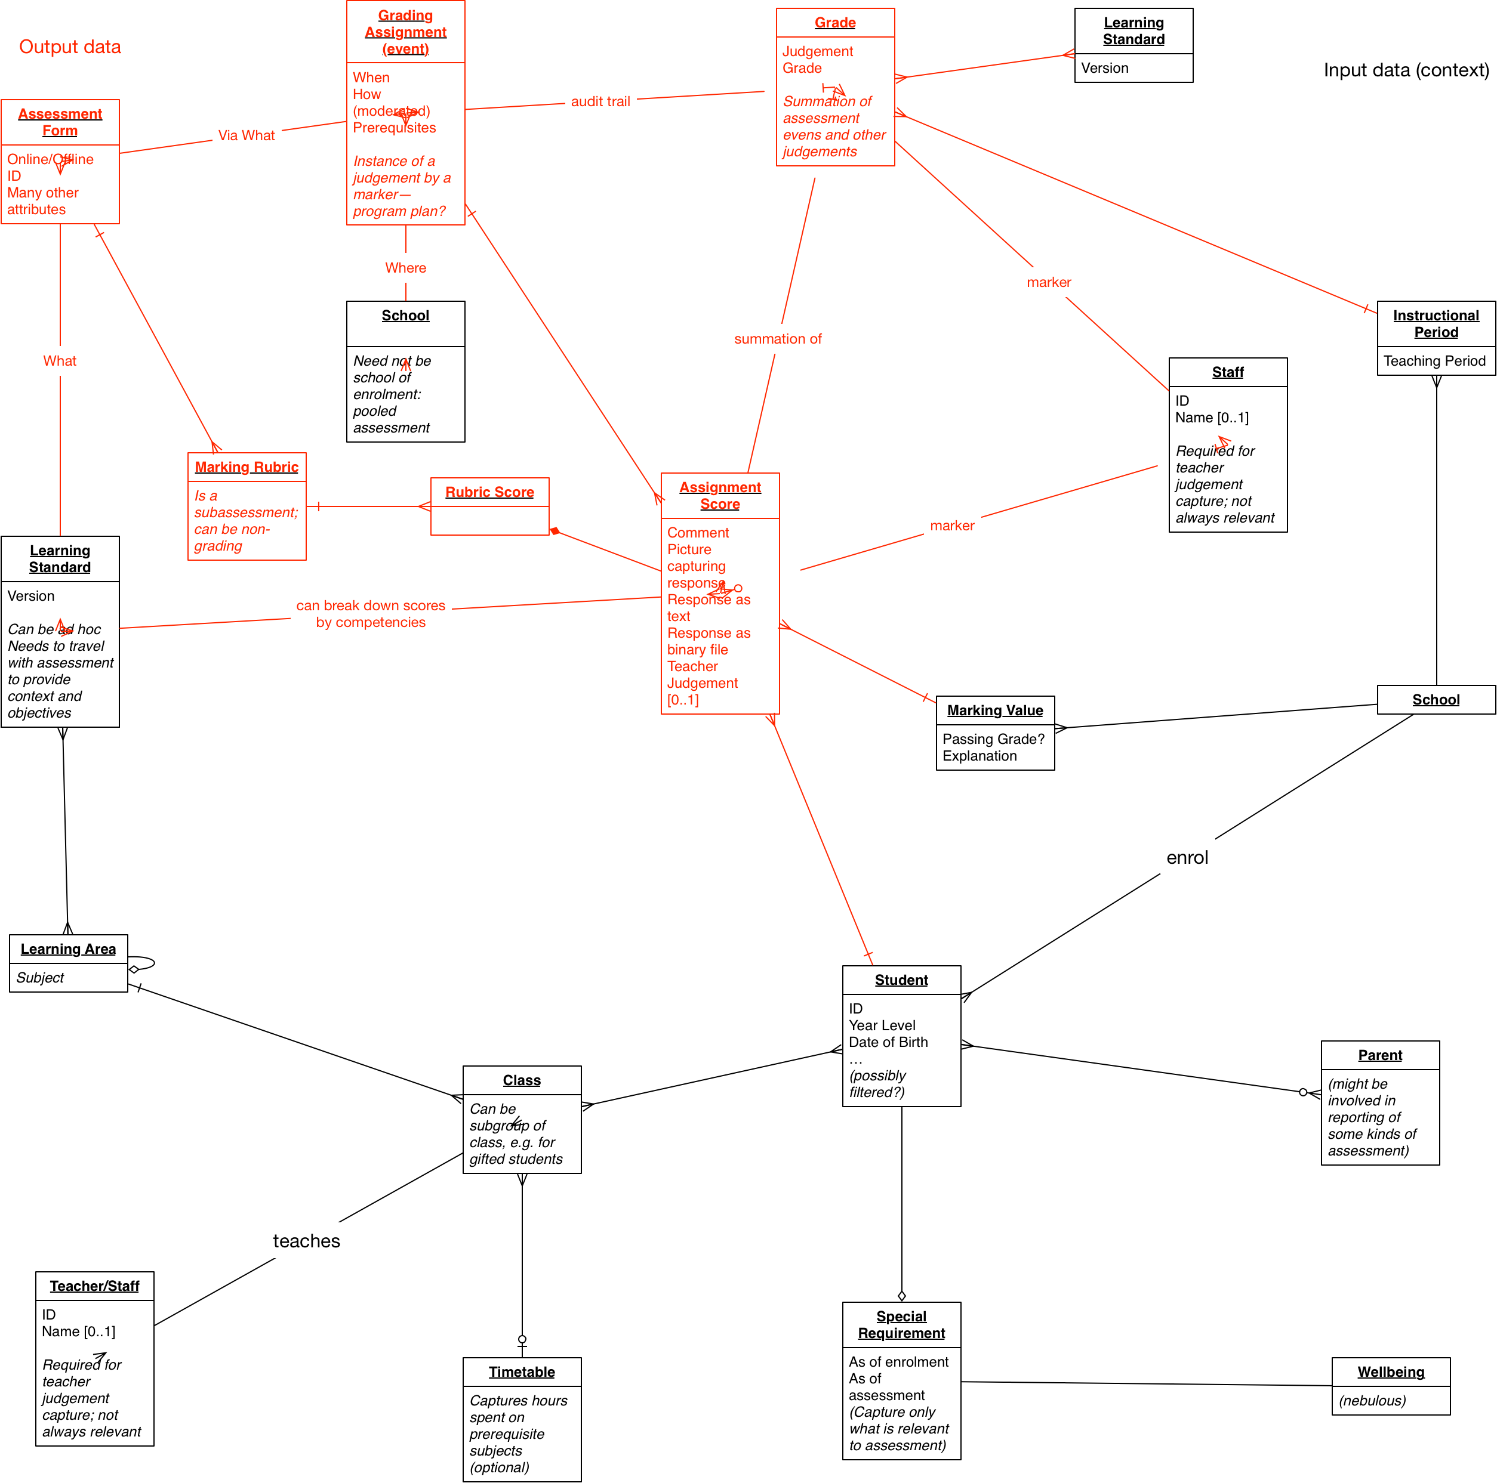

(Black objects refer to inputs to assessment, red refer to outputs of assessment.)

| ***Subject*** | ***relationship*** | ***Object*** |
| --- | --- | --- |
| Staff | Teaches | Class |
| Student | Is Member of | Class |
| Class | Studies | Learning Area |
| Grading Assignment | Assigned to | Class |
| Learning Standard | Covers | Learning Area |
| Learning Standard Authority | Issues | Learning Standard |
| Grading Assignment (event) | Assesses Performance Against | Learning Standard |
| Grading Assignment (event) | Delivered Through | Assessment Form (instrument) |
| Grading Assignment (event) | Has | Assignment Submission |
| Student | Submits | Assignment Submission |
| Assignment Submission | Receives | Assignment Score |
| Grading Assignment (event) | Receives | (Expected) Assignment Score |
| Grading Assignment (event) | Receives | (Final) Assignment Score |
| Assessment Form | Marked Against | Marking Rubric |
| Marking Rubric | Receives | Rubric Score |
| Assignment Score | Consists of | Rubric Score |
| Assignment Score | Is Broken Down By | Learning Standard |
| Staff | Grades/Marks | Assignment Score |
| Student | Achieves | Assignment Score |
| Student | Has | Special Requirements |
| Special Requirements | Informs Interpretation Of | Assignment Score |
| Special Requirements | Informs Administration Of | Grading Assignment (event) |
| Grade | Includes | Assignment Score |
| Grade | Assesses Performance Against | Learning Standard |
| Grade | Covers | Learning Area |
| Grade | Specific To | Instructional Period (e.g. Term/Semester) |
| Staff | Grades | Grade |
| Student | Receives | Grade |
| Assignment Score | Scaled To | Marking Value |
| Grade | Scaled To | Marking Value |
| School | defines | MarkInfo |

## Logical Model

|  |  |
| --- | --- |
| ***Conceptual object*** | ***Logical realisation*** |
| Assessment Form | GradingAssignment/DetailedDescriptionURL, GradingAssignment/DetailedDescriptionBinary  *(current encoding is bound 1:1 to the grading assignment, which is intended as a lightweight encoding)* |
| Assignment Submission | GradingAssignmentScore/[DraftIteration != nil]  *(SIF-AU is not currently proceeding with a separate Assignment Submission object, and is not incorporating the student script in the data model. Instead, SIF-AU uses multiple instances of GradingAssignmentScore, with the DraftIteration indicating which iteration of marking is represented.)* |
| Assignment Score | GradingAssignmentScore |
| Class | TeachingGroup |
| Grade | StudentGrade |
| Grading Assignment | GradingAssignment |
| Learning Area | StudentGrade/LearningArea, GradingAssignment/LearningStandardList/LearningArea |
| Learning Standard | GradingAssignment/LearningStandardList/LearningStandard |
| Learning Standard Authority | GradingAssignment/LearningStandardList/LearningStandard/ LearningStandardDescription/Curriculum |
| Marking Rubric | GradingAssignment/RubricList/Rubric |
| Marking Value | MarkValueInfo |
| Rubric Score | GradingAssignmentScore/SubscoreList/Subscore |
| Special Requirements | Personal Needs and Preferences (not modelled for Gradebook assessment) |
| Staff | StaffPersonal |
| Student | StudentPersonal |
| Term | TermInfo |

## Workflows

### Formative Assessment within school:

Input:

* StudentPersonal
* StaffPersonal
* TeachingGroup
* GradingAssignment
  + Form
  + Prerequisite
  + Rubric

Output:

* GradingAssignmentScore
  + Student Response
  + Teacher Judgement
  + Grade
  + Subscores

Steps:

* Teacher assigns GradingAssignment to TeachingGroup
* Alt: Teacher assigns different GradingAssignments to different students within the TeachingGroup, based on the students’ Personal Needs and Preferences and the properties of the GradingAssignment.
  + This selection process is treated as happening out of band, and is not reflected in attributes of GradingAssignment. (For secondary assessment, Personal Needs and Preferences are represented explicitly.)
* Optional: Student demonstrates that they satisfy the prerequisites for the GradingAssignment, in order for their attempt to be graded
* Student in TeachingGroup attempts GradingAssignment, by responding to GradingAssignment form
* Student in TeachingGroup submits GradingAssignment response
* Teacher grades GradingAssignment response, resulting in GradingAssignmentScore
  + Optional: where GradingAssignment rubrics are present, Teacher assigns subscores specific to the rubrics
* Teacher circulates GradingAssignmentScore (grade, judgement, subscores) to Student as feedback
* Teacher records GradingAssignmentScore in markbook for student
* Optional: GradingAssignmentScore incorporates GradingAssignment response

### Formative Assessment within school, remedial use:

Input:

* StudentPersonal
* StaffPersonal
* TeachingGroup
* GradingAssignment
  + Form
  + Subassignments
  + Learning Standards

Output:

* GradingAssignmentScore
  + Student Submission
  + Teacher Judgement
  + Grade
  + Subscores
  + Learning Standard breakdown of score

Steps:

* Teacher assigns GradingAssignment to TeachingGroup
  + Related LearningStandards captured for GradingAssignment
  + Details of GradingAssignment components (e.g. items) captured as subassignments of the GradingAssignment
* Alt: Teacher assigns GradingAssignment to individual Student, outside context of TeachingGroup (e.g. remedially).
* Student attempts GradingAssignment, by responding to GradingAssignment form
* Student submits GradingAssignment response
* Teacher grades GradingAssignment response, resulting in GradingAssignmentScore
  + Scores of individual subassignments of the GradingAssignment captured as GradingAssignmentScores specific to those subassignments
  + Score breakdown is captured for individual Learning Standards
* Teacher circulates GradingAssignmentScore (grade, judgement, subscores) to Student as feedback
* Teacher uses Learning Standards breakdown of GradingAssignmentScore, and score breakdown by subassignment, to identify particular areas of weakness for student performance
* Teacher devises teaching plan using resources to reinforce learning for student around problem areas identified

### Formative Assessment within school, multiple submissions:

Input:

* StudentPersonal
* StaffPersonal
* TeachingGroup
* GradingAssignment
  + Form

Output:

* GradingAssignmentScore
  + Student Response
  + Teacher Judgement
  + Grade
  + Subscores

Steps:

* Teacher assigns GradingAssignment to TeachingGroup
* Student in TeachingGroup attempts GradingAssignment, by responding to GradingAssignment form
* Repeat:
  + Student in TeachingGroup submits GradingAssignment draft response
  + Teacher grades GradingAssignment response, resulting in GradingAssignmentScore
  + Teacher circulates GradingAssignmentScore (grade, judgement, subscores) to Student as feedback
* Student in TeachingGroup submits GradingAssignment final response
* Teacher grades GradingAssignment response, resulting in GradingAssignmentScore
* Teacher circulates GradingAssignmentScore (grade, judgement, subscores) to Student as feedback
* Teacher records GradingAssignmentScore in markbook for student
* Optional: GradingAssignmentScore incorporates GradingAssignment response

### Subject Assessment within school, grade:

Input:

* StudentPersonal
* StaffPersonal
* TeachingGroup
* GradingAssignmentScore
* TermInfo

Output:

* StudentGrade
  + Teacher Judgement
  + Mark

Steps:

* Teacher performs formative assessments of Student in TeachingGroup
* Teacher records GradingAssignmentScores in markbook for student
* Teacher assesses Student’s overall performance in TeachingGroupduring Term as a mark, based on performance evaluated in GradingAssignmentScore, and other sources
* Optional: Teacher makes teacher judgement of Student’s overall performance in TeachingGroupduring Term
* Teacher assigns StudentGrade to student
* Teacher records StudentGrade in markbook for student

### Reporting of Assessment:

Input:

* GradingAssignmentScore
* StudentGrade
* TermInfo
* WellbeingCharacteristic

Steps:

* StudentGrades assigned to students for the term gathered from markbook
* Optional: GradingAssignmentScores assigned to students gathered from markbook, as supporting evidence for grades
  + GradingAssignmentScores do not contain details of subscores, breakdown by learning standard, breakdown by subassignments
* Optional: WellbeingCharacteristic provided for students where applicable to contextualise their performance
* StudentGrades and GradingAssignmentScores forwarded for reporting

### Student Transfer:

Input:

* GradingAssignment
  + Learning Standard
  + PersonalNeedsAndPreferences
* GradingAssignmentScore
* StudentGrade
* TermInfo
* MarkValueInfo
* WellbeingCharacteristic

Steps:

* Optional: Degree of detail required for student transcript negotiated between sending and receiving school
  + An SMS will likely only need to process summary data
  + An LMS may need to process granular assessment data, though it may not end up storing it in the long term
* StudentGrades assigned to students for the term gathered from markbook
* MarkValueInfo objects created to accompany StudentGrades, providing interpretation of StudentGrade
* Optional: GradingAssignmentScores and GradingAssignments underlying StudentGrade gathered from markbook, as representative sample of work
  + Where applicable, MarkValueInfo objects created to accompany GradingAssignmentScores, providing interpretation of StudentGrade
  + Details of Learning Standards specific to GradingAssignments made explicit for external consumption, as proof of competency
* Optional: WellbeingCharacteristic provided for students where applicable (and conformant with privacy constraints) to contextualise their performance
* Optional: PersonalNeedsAndPreferences (derived from WellbeingCharacteristic) used to select appropriate GradingAssignment to administer to student
* StudentGrades, GradingAssignmentScores and GradingAssignments forwarded as part of student transcript

# Credentials and Attainments

The data model has been enhanced to add the following objects:

* Credential: An educational achievement available to be reached by a student through their studies.
  + Qualifications are credentials.
  + Credentials are managed by credentialing/qualifications authorities, which are typically not the school but an external agency.
  + Successful completion of a course of study can constitute a Credential.
  + Students register with an intent to undertake a Credential
* A in pursuit of a Credential
  + Classes themselves (both prior credentials, as recognition of prior learning towards the current credential; and the current credential itself)
  + Attainments are abstract types; logically they will be realised by Assessments, Courses, Classes, and Credentials.
* StudentAttainment: A record of how a student has achieved or is progressing towards an Attainment.
  + The Attainment can be a Credential, or other Attainments undertaken in pursuit of a Credential. StudentAttainments are recursive.
  + Student Attainments can have associated teacher judgements.
  + Student Attainments can include Credits that a student has accumulated through their engagement with the Attainment.
  + Credentials can be achievement through accumulation of Credits associated with Attainments
  + Credits can be related to individual learning standards or learning areas.
  + Information on what Credentials students are engaging with (though StudentAttainments) are of interest to the authorities managing the credentials.
  + Information on what competencies have been acquired by a student in their studies, as represented in StudentAttainment records, are of interest in student transfer, as they can be used for Recognition of Prior Learning.
    - For the bulk of RPL scenarios, students are transferring within a jurisdiction where qualification/credential frameworks are well known. This means that for the purposes of RPL during student transfer, the object can be published without any information about the qualification or Credential itself, or with only minimal identifying information.

## Conceptual Model



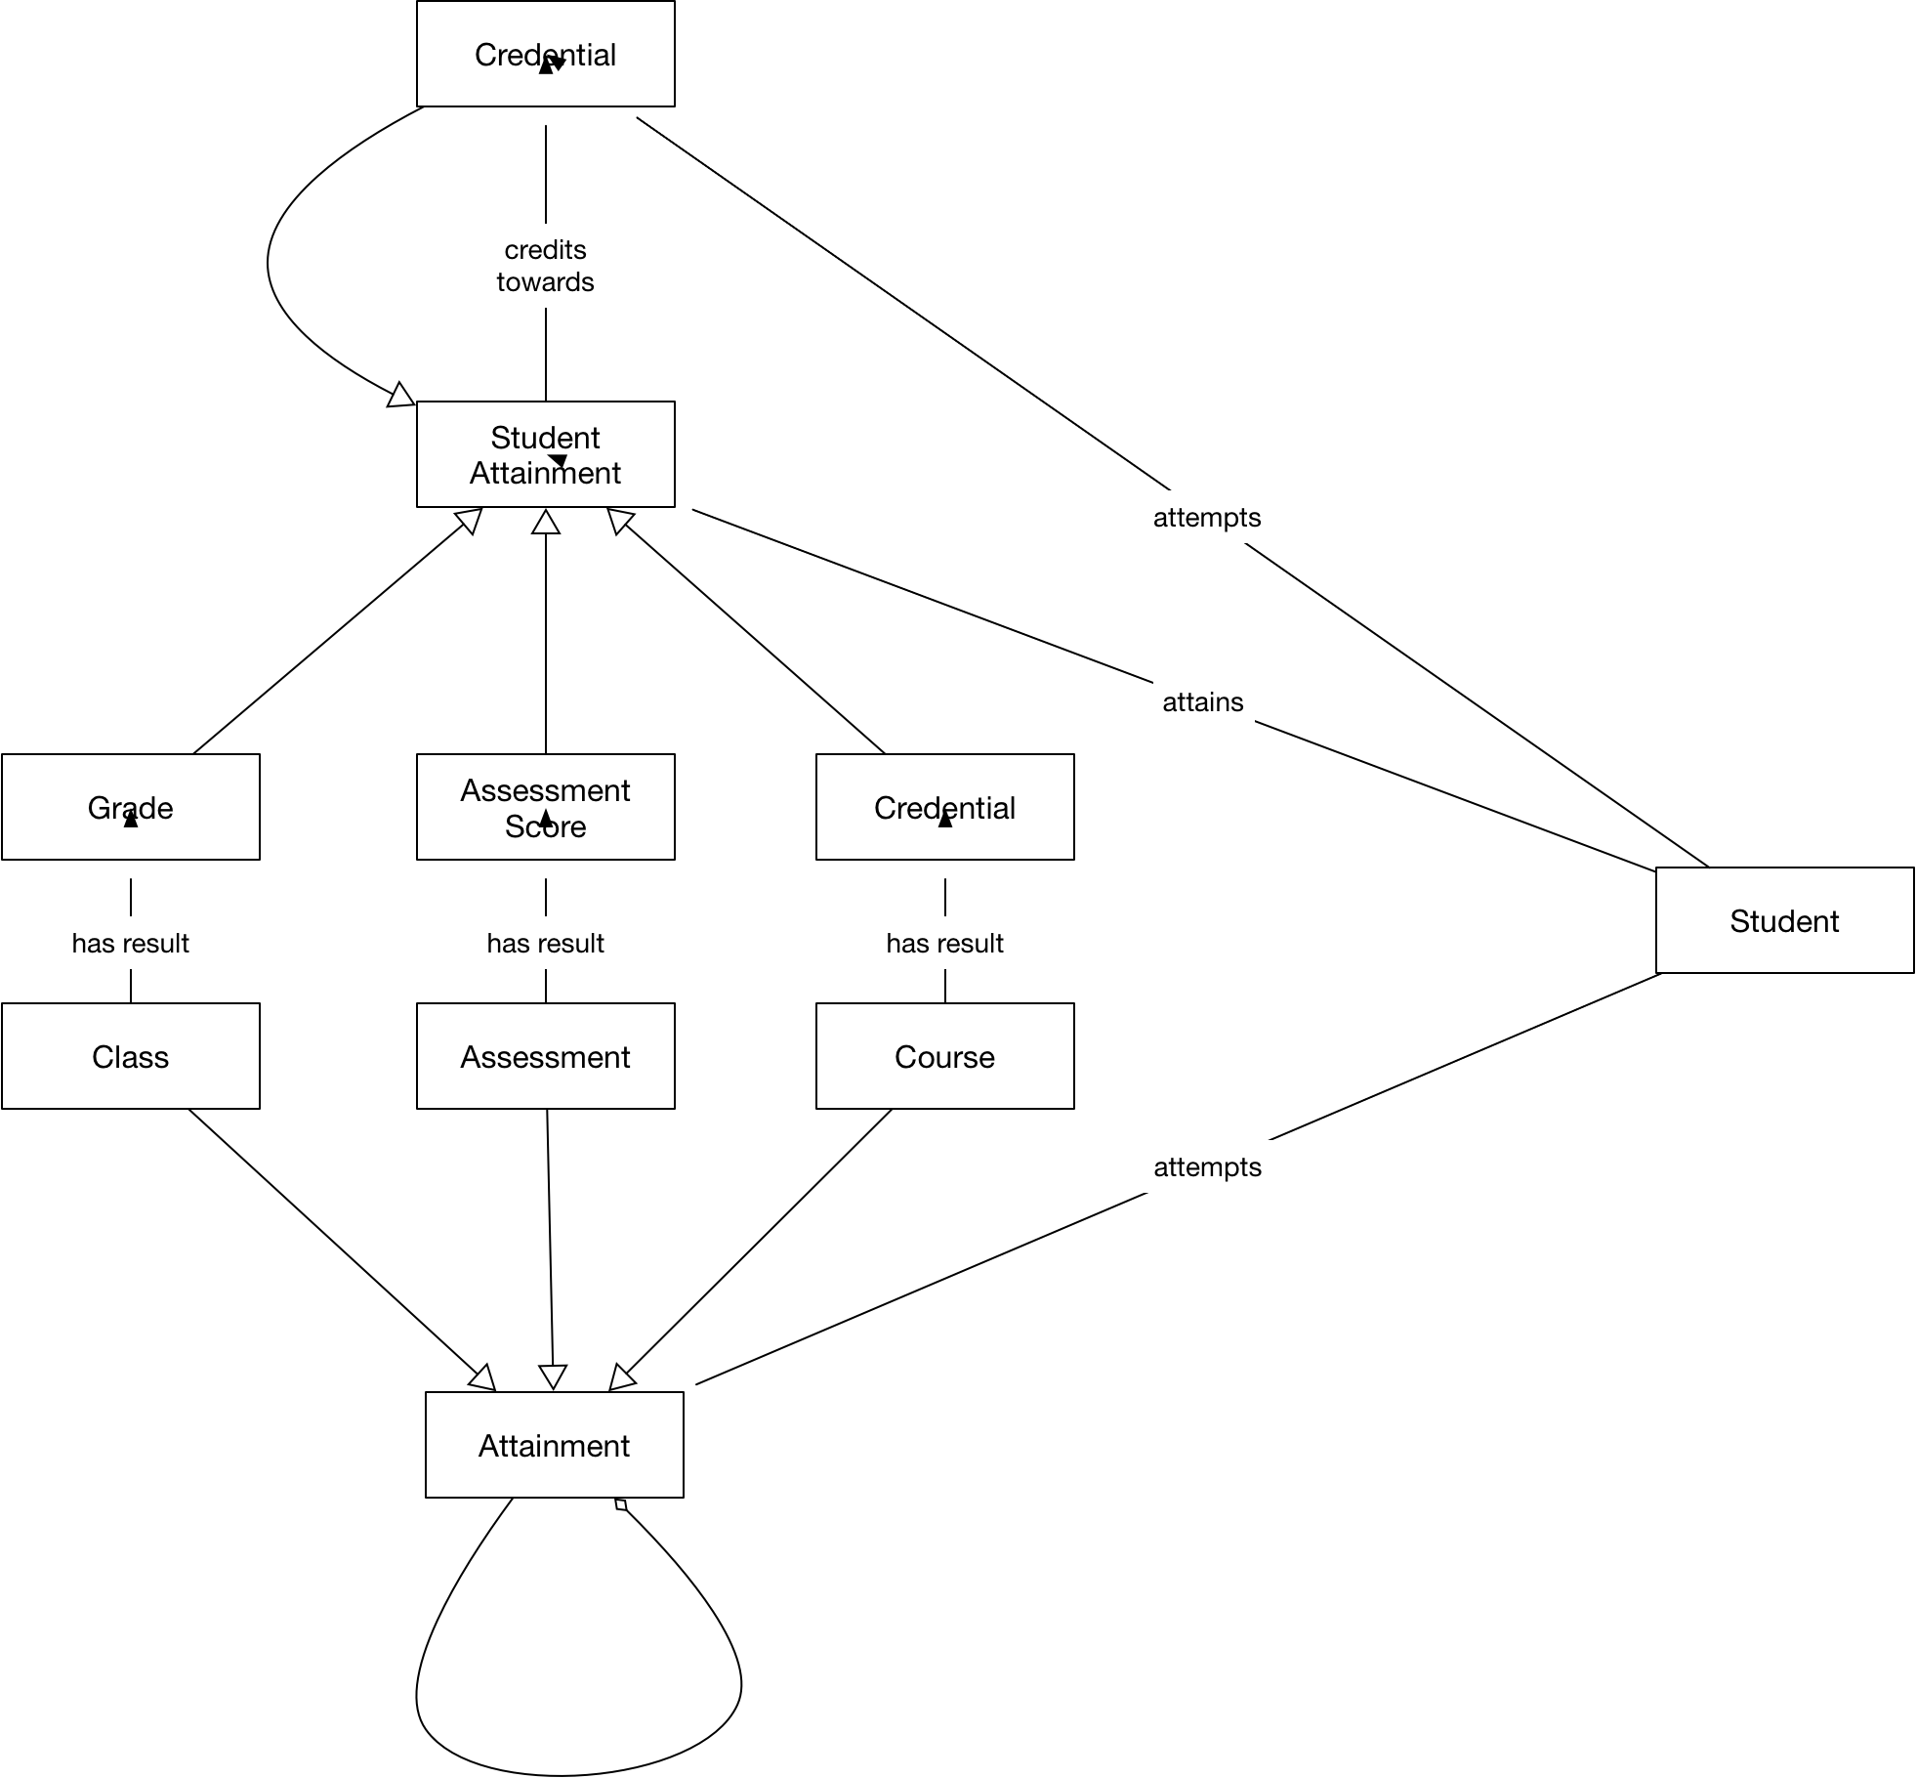



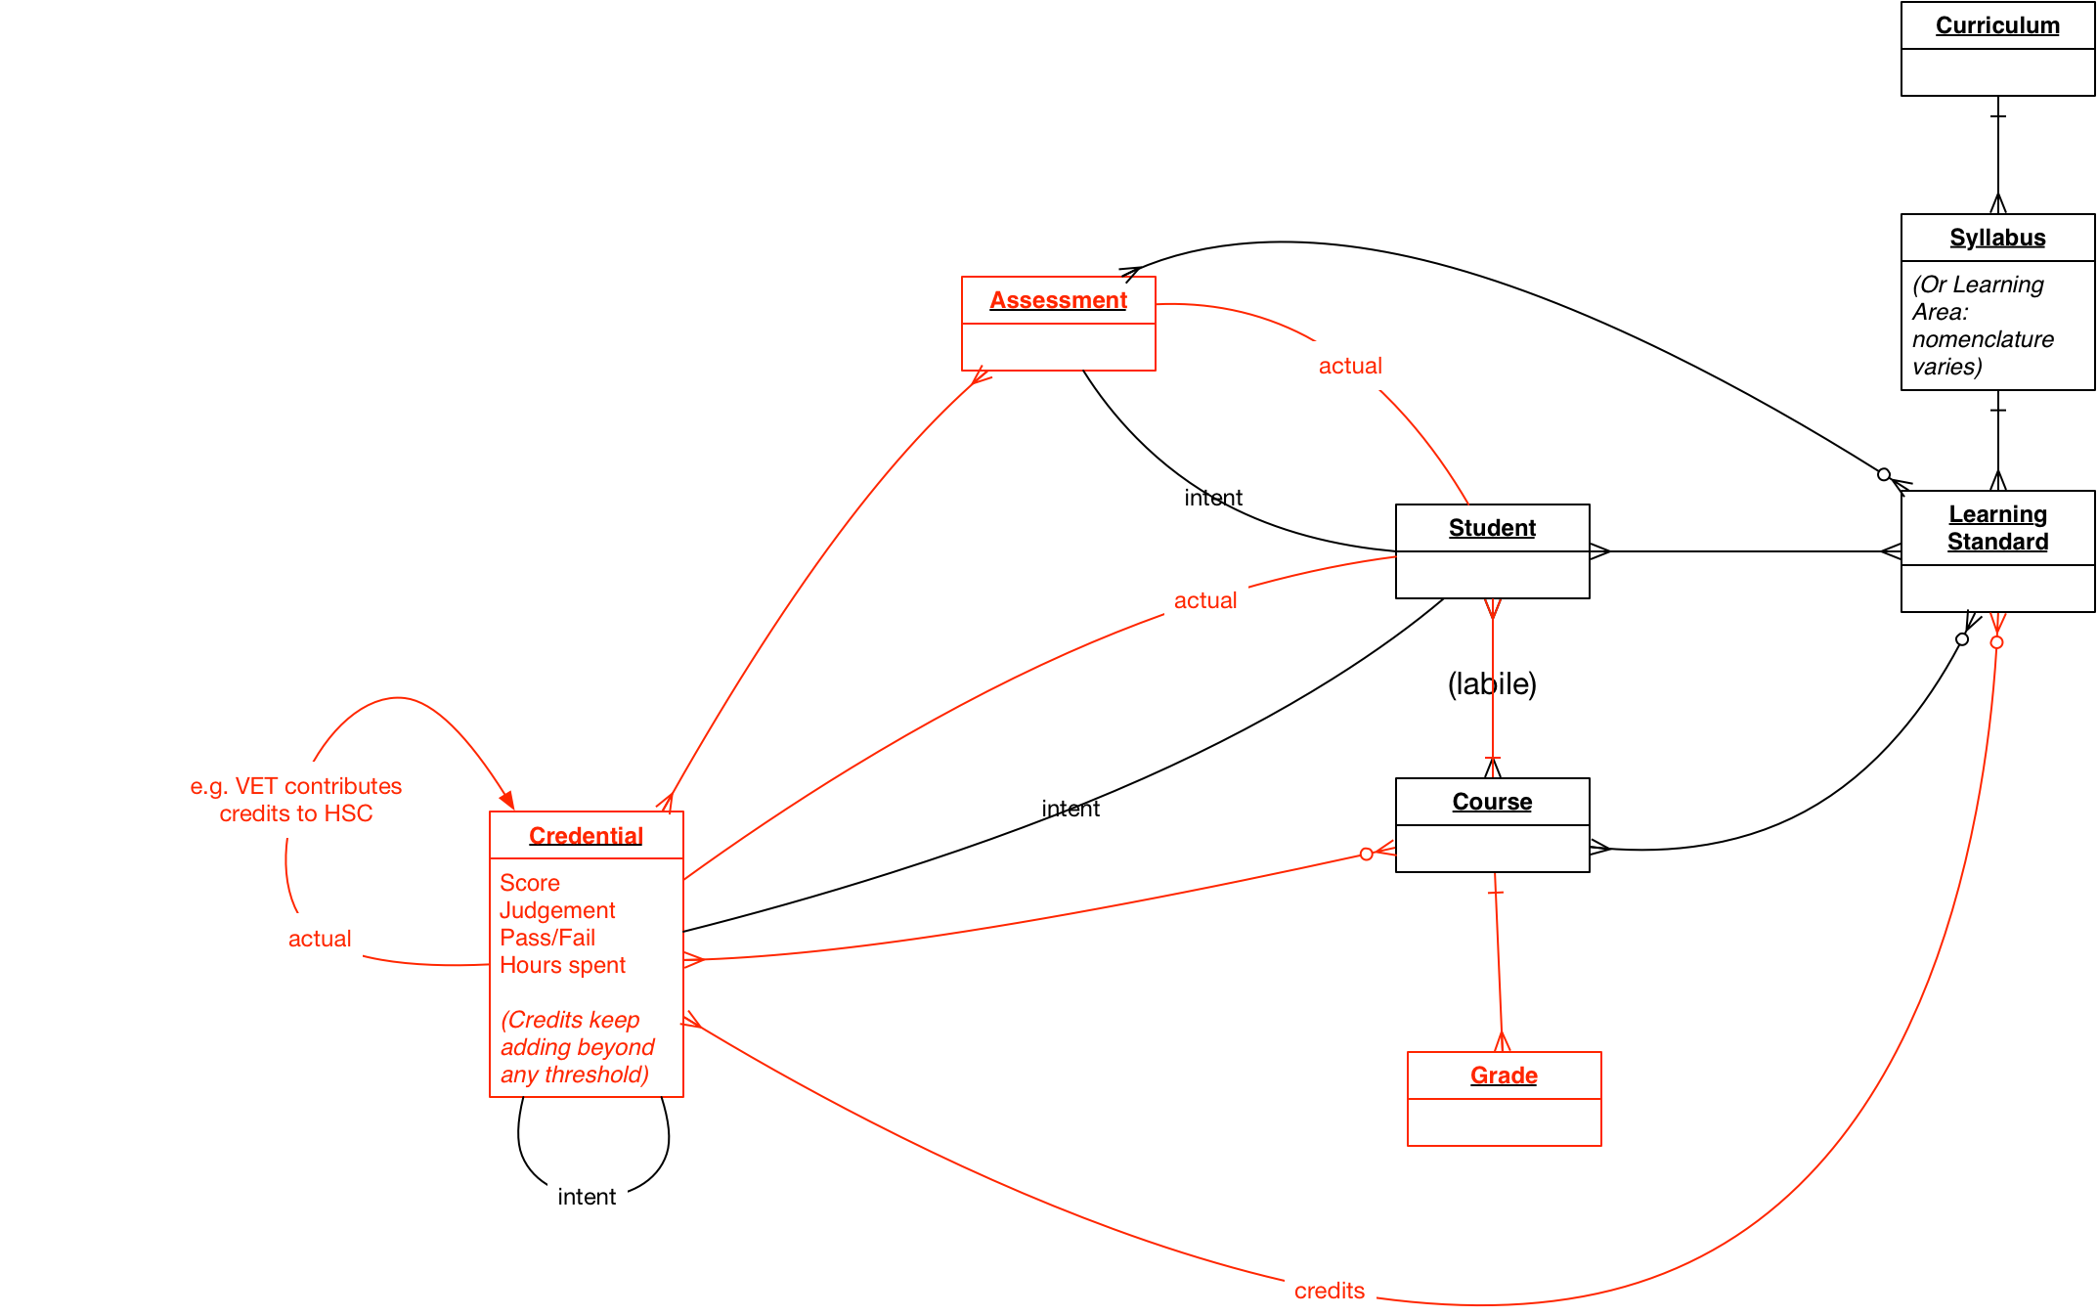

(Black objects refer to inputs to assessment, red refer to outputs of assessment.)

| ***Subject*** | ***relationship*** | ***Object*** |
| --- | --- | --- |
| Learning Standard | Covers | Learning Area |
| Curriculum | Includes | Learning Area |
| Curriculum | Includes | Learning Standard |
| Course | Covers | Learning Area |
| Course | Covers (changeable) | Learning Standard |
| Student | Enrolled In (flexible) | Course |
| Student | Completes (Attains) | Course |
| Student | Member | Class |
| Course | Delivered Through (changeable) | Class |
| Student | Registers For | Assessment (event) |
| Student | Attempts | Assessment (event) |
| Assessment (event) | Receives provisional | Assessment Score |
| Assessment (event) | Receives final | Assessment Score |
| Student | Attains | Assessment Score |
| Assessment Score | Broken Down By | Learning Standard |
| Student | Attains | Grade |
| Grade | Is Result Of | Class |
| Grade | Is Result Of | Course |
| Student | Registers For | Credential |
| Student | Attains | Credential |
| Assessment Score | Is A | Student Attainment |
| Grade | Is A | Student Attainment |
| Credential | Is An | Attainment |
| Assessment | Is An | Attainment |
| Class | Is An | Attainment |
| Course | Is An | Attainment |
| Student | Registers for | Attainment |
| Student | Attempts | Attainment |
| Student | Achieves | Student Attainment |
| Student Attainment | Assesses Performance on | Attainment |
| Student Attainment | Credits Towards | Credential |
| Assessment Score | Credits Towards | Credential |
| Course | Results in | Credential |
| Credential | Has contributions measured in | Credits |
| Credits | Are awarded against | Student Attainments |
| Credits | Are broken down by | Learning Standard |
| Grade | Is broken down by | Learning Standard |
|  |  |  |

The relation of Credentials to Attainments (classes, courses, assessments, credentials) and Learning Standards is increasingly loosely coupled, but it will change over years rather than days or months. This is addressed by republishing any Credential objects linking to classes, courses, learning standards and assessments, as the relations change.

The relation of students to Attainments (including Credentials) that they register for is unstable, and can change in a matter of days. That requires join objects for internal representation, rather than embedding them in a snapshot transcript object. A snapshot transcript is appropriate, however, for presentation of a student’s intentions and progress to date on student transfer.

## Logical Model

* There is a preexisting object for StudentPersonal.
* Existing objects are used to represent Attainments. The Attainment can be an Exam-style Assessment, an Assignment, a Course Unit (TeachingGroup; Section in SIF-US), a Course of Study, or a Credential.
* There is a new object called StudentAttainment, which associates successful performance by a Student against a Attainment. The StudentAttainment links to the Student and to the Attainment. It further contains a score measuring student progress, a credits measure quantifying their progress for the purpose of Credentials (see below), and learning standards which the student has demonstrated competency in.
  + The StudentAttainment of an Exam-style Assessment only gives the overall score. For breakdown of individual responses, psychometrics, and more specifics on the exam response, a distinct object is required.
* There is a new object describing Credentials, which students can register for, work towards, and achieve.
* There is a new object describing the progress a student has made towards achieving a Credential: the StudentCredentialAttainment. (This is a subclass of StudentAttainment.) This object links to the Student and the Credential. It also links to one or more Attainments, as evidence of progress or justification of the StudentCredentialAttainment. (Note that Attainments can be consumed as objects independently.)
* A listing of Attainments can be consumed, without information about a Credential, as a Student Transcript.

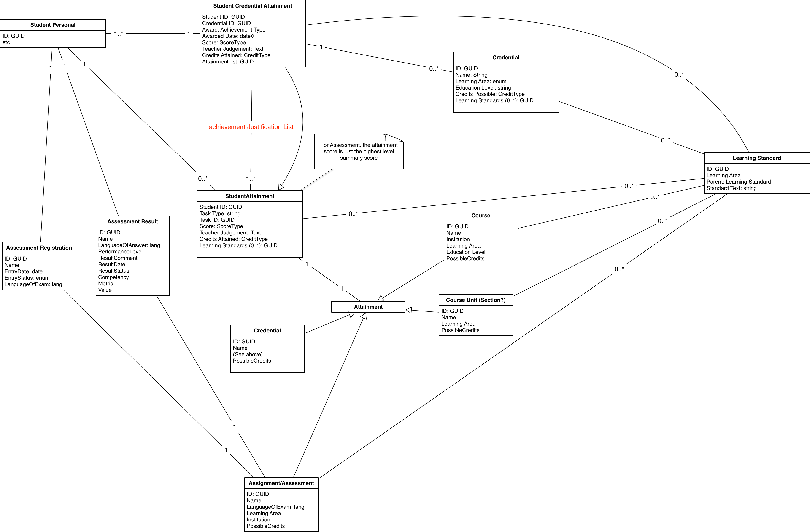

| ***Conceptual object*** | ***Logical realisation*** |
| --- | --- |
| Assessment (event) | Assessment (to be done) |
| Assessment Score | AssessmentScore (to be done) |
| Course | SchoolCourseInfo |
| Class | TeachingGroup or Section |
| Curriculum | LearningStandardDocument (current SIF approach) |
| Grade | StudentGrade, StudentAttainment/Score |
| Learning Standard | */LearningStandardType, LearningStandardItem |
| Credential | Credential (initial starting point CEDS) |
| Student | StudentPersonal |
| Staff | StaffPersonal |
| WellbeingCharacteristic | WellbeingCharacteristic |

|  |  |  |
| --- | --- | --- |
| ***Relationship*** | ***Logical Entity*** | ***Comment*** |
| Student Member Class | TeachingGroup or StudentSectionEnrollment | TeachingGroup, SectionInfo |
| Student Enrolled in Course | (StudentCourseEnrollment) | (new object? But not necessary for data exchange) |
| (Class/ LearningStandards) |  | SIF has to date treated this only as metadata of SectionInfo |
| Grade is Broken Down by Learning Standard | Grade/ LearningStandardsBreakdown |  |
| (Course/ LearningStandards) | Course/LearningStandardList/*, LearningStandardItem | SIF has to date treated this only as metadata of SchoolCourseInfo |
| (Course/ Assessment) |  | (not necessary for data exchange, is captured in StudentAttainment) |
| Course Delivered Through Classes | SectionInfo/  SchoolCourseInfoRefId |  |
| Assessment Covers Learning Standard | Assessment/LearningStandardList/*, LearningStandardItem | (not necessary for data exchange, is captured in StudentAttainmentAchievement) |
| Course Results in Credential | SchoolCourseInfo/CredentialList/* | Add SchoolCourseInfo/CredentialInfo, but not necessary for data exchange. |
| Student Registers for Assessment | StudentAssessmentRegistration | (not yet provided) |
| Student Receives Assessment Score, Assessment Receives final Assessment Score | StudentAssessmentScoreSet/ Assessment Results | (not yet provided) |
| Assessment score is broken down by Learning Standards | (StudentAssessmentScoreSet/ LearningStandardsBreakdown) | (not yet provided) |
| Grade Credits Towards Credential |  | (not necessary for data exchange, is captured in StudentCredentialAttainment) |
| Assessment Score Credits Towards Credential |  | (not necessary for data exchange, is captured in StudentCredentialAttainment) |
| Course Credits Towards Credential |  | SchoolCourseInfo/CourseCredits could be used, though that locks credits to course; the credits are attributes of the Credential, and different Credentials can award different credits to a course. This may not be a concern. At any rate, not necessary for data transfer. (Not required for NZ – credits to Credential come from the LearningStandards.) |
| Credential Credits Towards Credential |  | (not necessary for data exchange, is captured in Credential achievement) |
| Credits are Broken down by Learning Standard | StudentAttainment/Credits/ LearningStandard | (not necessary for data exchange, is captured in Credential achievement) |
| Student Registers For Credential | StudentCredentialEnrolment | (not provided yet, not necessary for data exchange) To be provided: required e.g. to provide NZQA visibility of student intent. |
| Student Achieves Credential | StudentCredentialAttainment | CEDS: Credential Award |
| Student Achievement is measured through Attainments | StudentCredentialAttainment/ AttainmentList |  |
| Credential has Contributions Measured in Credits | StudentCredentialAttainment/ SummaryScoreInfo/CreditList |  |
| Attainment Contribution is Measured in Credits | (AttainmentTask)/Credits |  |
| Credential Establishes Competence in Learning Standards | StudentCredentialAttainment/ LearningStandard |  |
| Credits are Broken Down by Learning Standard | StudentCredentialAttainment/ SummaryScoreInfo/ LearningStandardList/ LearningStandard/Credit,  Attainment/ LearningStandardList/ LearningStandard/Credit | …actually broken down by LearningArea. ie: how many STEM credits? How many Literacy&Numeracy credits? |
| Attainment is Specific to Attainment Task | StudentAttainment/TaskID, StudentAttainment/TaskType |  |
| AttainmentTask Has Maximum Possible Credits | CourseInfo/PossibleCredits, Assessment/PossibleCredits, Class/PossibleCredits, Credential/PossibleCredits | Element to be added to those objects  NZ Perspective: LearningStandards have a single credit value.  Credentials require certain numbers of credits to have been achieved.  There is no maximum no of credits. |

### StudentAttainment

The StudentAttainment object tracks the progress that a student makes against assessments, courses, course units = classes and credentials. This progress is quantified in terms that can be used to demonstrate progress towards a credential, including an overall score, credits accumulated, and learning standards covered:

* Information about the attainment (e.g. class details, assessment description), at a level of detail mutually agreed to be useful between sender and receiver
* An optional link to a GUID for an object giving more information about the attainment. This will be, for the four different types of attainment, a CredentialInfo object (for previous credentials), a SchoolCourseInfo object (for courses), an AssessmentInfo object (for assessments, not currently in specification), and a SectionInfo object (for course units).
* Information about the associated attainment by the student (e.g. score)
* List of any credits accumulated towards the credential through that attainment (optional)
* List of any learning standards or competencies demonstrated by that attainment
  + Optionally: breakdown of credits by the particular learning standards or competencies (requirement from NZ to be confirmed)

*In this prototype, we allow multiple types of credit, each with a distinct type and value. If a single credit type is assumed throughout Australasian education, the type does not need to be specified.*

*Alternatively, credits may be substituted by credit elements explicitly typed; e.g. <hoursOfStudy>821</hoursOfStudy> or <carnegieUnits>1.2</carnegieUnits>. Australian credentials do not to our knowledge rely on credits, and credits in the object should be optional. An Australian object may choose to leave credits out completely at this stage, and leave them for the NZ object.*

### StudentCredentialAttainment

*This object tracks the academic record of attainments that a student has accumulated in pursuit of a single credential. The information contained in the StudentCredentialAttainment may be repeated for different credentials, adding up to a student transcript containing all the student’s attainments. The information in the object may be provided, without the credentialInfo container and the summaryScoreInfo, as a transcript on its own—in which case the information is not specific to any one credential.*

*The StudentCredentialAttainment optionally links to a Credential object providing more information about the Credential (its name, its authority, its year level), if the StudentCredentialAttainment is in fact specific to a Credential. Information at the level of the CredentialDetails object (see Appendix) is not intended to be transmitted between parties: that level of detail is only needed internally to a teaching jurisdiction, and will already be shared knowledge. The information in any Credential object may well be limited enough to convey within a StudentCredentialAttainment object.*

*The StudentCredentialAttainment provides an overall score, and optional teacher judgement. The StudentCredentialAttainment may also provide the total credits accumulated by the student in pursuit of the Credential; if it does so, it should contextualise the credit count against the maximum possible credits for the Credential, and the amount of credits needed to pass.*

*The StudentCredentialAttainment tracks as Attainments the progress that a student makes against assessments, courses, course units = classes and RPL credentials in order to achieve the Credential. These are of interest for RPL, and as justification for the awarding of the StudentCredentialAttainment. Attainments are separate objects linked to from the StudentCredentialAttainment, containing a score, credits, learning standards covered, and a link to the task attempted.*

*The StudentCredentialAttainment object tracks the Learning Standards that have be achieved by the student overall, and optionally apportions an optional breakdown of credits against each.*

The high-level structure of the object is:

StudentCredentialAttainment:

* CredentialInfo: data about the credential (optional); links to a Credential object
* SummaryScoreInfo: overall score reached for the credential
* AttainmentList: links to descriptions of performance against tasks undertaken towards this credential; those tasks include course units (outside the context of a course), courses, assessments, and previous credentials.
* CredentialList: links to/description of credentials undertaken towards this credential

Without information about the credential, the object can serve as a student transcript, capturing all study undertaken by the student (and associated attainments), regardless of credential they were pursuing:

StudentTranscript:

* AttainmentList

Note that details of the credentials being attempted, and the associated credits breakdown, are not needed in student transfer, if the credential is not valid in the receiving school: the school in that case is only interested in RPL, which is addressed by the listing of studies and their associated competencies.

If the StudentCredentialAttainment is repeated within a transcript, that becomes a transcript object broken down by Credential.

### NZ Examples

#### Learning Standard Object

<LearningStandard RefId=”ALGEBRA1-LEARNING-STANDARD-GUID”>

<authority SIF_refType=”Credential_Authority”>NZQA</authority>

<Name>Level 1 Algebra</Name>

<LocalId>55663</LocalId> <!-- NZQA Learning Standard No -->

<Version>2</Version> <!-- they get updated by NZQA -->

<LearningArea>Maths</LearningArea>

<LearningStandardType>AssessmentStandard</LearningStandardType>

<!-— which means possible scores are NAME:

N(ot achieved), A(chieved), M(erit), E(xcellence -->

<CreditValue>4</CreditValue>

<AssessmentMode>External</AssessmentMode>

</LearningStandard>

<!-- and three more -->

<LearningStandard RefId=”TRIGONOMETRY1-LEARNING-STANDARD-GUID”>

<Name>Level 1 Trigonometry</Name>

<LocalId>55664</LocalId>

<Version>1</Version>

<LearningArea>Maths</LearningArea>

<LearningStandardType>AssessmentStandard</LearningStandardType>

<CreditValue>4</CreditValue>

<AssessmentMode>External</AssessmentMode>

</LearningStandard>

<LearningStandard RefId=”STATISTICS1-LEARNING-STANDARD-GUID”>

<Name>Level 1 Statistics</Name>

<LocalId>55665</LocalId>

<Version>1</Version>

<LearningArea>Maths</LearningArea>

<LearningStandardType>AssessmentStandard</LearningStandardType>

<CreditValue>4</CreditValue>

<AssessmentMode>External</AssessmentMode>

</LearningStandard>

<LearningStandard RefId=”ACIDS-LEARNING-STANDARD-GUID”>

<Name>Level 1 Acids & Bases</Name>

<LocalId>44552</LocalId>

<Version>1</Version>

<LearningArea>Chemistry</LearningArea>

<LearningStandardType>AssessmentStandard</LearningStandardType>

<CreditValue>4</CreditValue>

<AssessmentMode>Internal</AssessmentMode>

</LearningStandard>

#### Credential Object

<Credential RefId=“NCE1-CREDENTIAL-GUID”>

<authority SIF_refType=”Credential_Authority”>NZQA</authority>

<name>NCEA Level 1</name>

<scoreType>AME</scoreType>

</Credential>

#### Assessment Attainment Object

<Attainment>

<TaskRefId>f000000002</TaskRefId>

<TaskType>Assessment</TaskType>

<!-- Real exams have NZQA as provider -->

<AuthorityProviderRefId>NZQA</AuthorityProviderRefId>

<AssessmentFamily>NCEA</AssessmentFamily>

<LearningStandardRefId>Trigonometry 1</LearningStandardRefId>

<AssessmentMode>External</AssessmentMode>

<AssessmentLocationId>Wellington College</AssessmentLocationId>

<StudentAssessmentList>

<StudentAssessment>

<ContributionType>Final</ContributionType>

<AssessmentFormRefId>exam paper no</AssessmentFormRefId>

<ScoreList>

<Score>

<Metric>NCEA Result</Metric>

<Score>Achieved</Score>

<Status>Final</Status>

</Score>

</ScoreList>

</StudentAssessment>

</StudentAssessmentList>

</Attainment>

#### Assessment Attainment - Multiple Students Object

<Attainment>

<!-- Internal Assessment on particular date, two students -->

<TaskRefId>f000000001-00000</TaskRefId>

<TaskType>Assessment</TaskType>

<AssessmentFamily>NZQA</AssessmentFamily>

<LearningStandardRefId>Algebra 1</LearningStandardRefId>

<AssessmentMode>Internal</AssessmentMode>

<StudentAssessmentList>

<StudentAssessment>

<StudentRefId>Tony</StudentRefId>

<AssessmentFormRefId>9MAT_2017</AssessmentFormRefId>

<ScoreList>

<Score>

<Metric>NAME</Metric>

<Value>Achieved</Value>

<Status>Final</Status>

</Score>

</ScoreList>

</StudentAssessment>

<StudentAssessment>

<StudentRefId>Andrew</StudentRefId>

<AssessmentFormRefId>9MAT_2017</AssessmentFormRefId>

<ScoreList>

<Score>

<Metric>NAME</Metric>

<Value>Merit</Value>

<Status>Final</Status>

</Score>

</ScoreList>

</StudentAssessment>

</StudentAssessmentList>

</Attainment>

#### Credential Attainment Object (NCEA Level 1)

<Attainment RefID= “CREDENTIAL-ATTAINMENT-GUID”>

<!-- Attainment of “NCE Level 1” Credential because student has accumulated enough credits from

Assessment Attainment objects. -->

<TaskRefID>f0000001-00000</ TaskRefID >

<TaskType>**Credential**</TaskType>

<!-- Attained NCEA Level 1 with Merit -->

<name>NCEA Level 1</name>

<scoreList>

<score>

<value>M</value>

<type>final</type>

</score>

</scoreList>

<!-- Full Credential Info available in ref -->

<CredentialInfo>

<Credential>NCEA1-CREDENTIAL-GUID</Credential>

</CredentialInfo>

<!-- NCEA Level 1 attained by passing attaining four learning standards, two with merit,

each contributing 4 credits -->

<CredentialLearningStandardList>

<CredentialLearningStandard>

<LearningStandard>ALGEBRA1-LEARNING-STANDARD-GUID</LearningStandard>

<credit><value>4</value></credit>

<score><value>M</value></score>

</CredentialLearningStandard>

<CredentialLearningStandard>

<LearningStandard>TRIGONOMETRY1-LEARNING-STANDARD-GUID</LearningStandard>

<credit><value>4</value></credit>

<score><value>A</value></score>

</CredentialLearningStandard>

<CredentialLearningStandard>

<LearningStandard>STATISTICS-LEARNING-STANDARD-GUID</LearningStandard>

<credit><value>4</value></credit>

<score><value>M</value></score>

</CredentialLearningStandard>

<CredentialLearningStandard>

<LearningStandard>ACIDS-LEARNING-STANDARD-GUID</LearningStandard>

<credit><value>4</value></credit>

<score><value>A</value></score>

</CredentialLearningStandard>

</LearningStandardList>

<!—- Alternatively could simply have AttainmentList -->

<AttainmentList>

<Attainment taskRefId=”f0000000001”/>

<Attainment taskRefId=”f0000000002”/>

<Attainment taskRefId=”f0000000003”/>

<Attainment taskRefId=”f0000000004”/>

</AttainmentList>

</Attainment>

#### Attainment List - Student Transcript

<StudentTranscript>

<StudentRefId>Tony</StudentRefId>

<AttainmentList>

<Attainment>

<TaskRefId>f000000001</TaskRefId>

<TaskType>Assessment</TaskType>

<!-- Mock exam has school as provider -->

<AuthorityProviderRefId>Wellington College</AuthorityProviderRefId>

<AssessmentFamily>NCEA</AssessmentFamily>

<LearningStandardRefId>Algebra 1</LearningStandardRefId>

<AssessmentMode>External</AssessmentMode>

<AssessmentLocationId>Wellington College</AssessmentLocationId>

<StudentAssessmentList>

<StudentAssessment>

<ContributionType>Mock</ContributionType>

<AssessmentFormRefId>247_9MAT_2017</AssessmentFormRefId>

<ScoreList>

<Score>

<Metric>NCEA Result</Metric>

<Value>Merit</Value>

<Status>Final</Status> <!-- Could be 'Provisional' -->

</Score>

</ScoreList>

<Comment>Well done Tony</Comment>

</StudentAssessment>

</StudentAssessmentList>

</Attainment>

<Attainment>

<TaskRefId>f000000002</TaskRefId>

<TaskType>Assessment</TaskType>

<!-- Real exams have NZQA as provider -->

<AuthorityProviderRefId>NZQA</AuthorityProviderRefId>

<AssessmentFamily>NCEA</AssessmentFamily>

<LearningStandardRefId>Trigonometry 1</LearningStandardRefId>

<AssessmentMode>External</AssessmentMode>

<AssessmentLocationId>Wellington College</AssessmentLocationId>

<StudentAssessmentList>

<StudentAssessment>

<ContributionType>Final</ContributionType>

<AssessmentFormRefId>exam paper no</AssessmentFormRefId>

<ScoreList>

<Score>

<Metric>NCEA Result</Metric>

<Score>Achieved</Score>

<Status>Final</Status>

</Score>

</ScoreList>

</StudentAssessment>

</StudentAssessmentList>

</Attainment>

<!-- Two attempts at passing Algebra 1 -->

<Attainment>

<TaskRefId>f000000003</TaskRefId>

<TaskType>Assessment</TaskType>

<AuthorityProviderRefId>NZQA</AuthorityProviderRefId>

<AssessmentFamily>NCEA</AssessmentFamily>

<LearningStandardRefId>Algebra 1</LearningStandardRefId>

<AssessmentMode>External</AssessmentMode>

<AssessmentLocationId>Wellington College</AssessmentLocationId>

<StudentAssessmentList>

<StudentAssessment>

<ContributionType>Provisional</ContributionType>

<AssessmentFormRefId>exam paper no 11</AssessmentFormRefId>

<ScoreList>

<Score>

<Metric>NCEA Result</Metric>

<Score>Achieved</Score>

<Status>Superseded</Status>

</Score>

</ScoreList>

</StudentAssessment>

<StudentAssessment>

<ContributionType>Final</ContributionType> <!-- This is the one that counts -->

<AssessmentFormRefId>exam paper no 12</AssessmentFormRefId>

<ScoreList>

<Score>

<Metric>NCEA Result</Metric>

<Score>Merit</Score>

<Status>Final</Status>

</Score>

</ScoreList>

</StudentAssessment>

</StudentAssessmentList>

</Attainment>

<Attainment>

<TaskRefId>f000000004</TaskRefId>

<TaskType>**Assessment**</TaskType>

<AuthorityProviderRefId>NZQA</AuthorityProviderRefId>

<AssessmentFamily>NCEA</AssessmentFamily>

<LearningStandardRefId>Statistics 1</LearningStandardRefId>

<AssessmentMode>External</AssessmentMode>

<AssessmentLocationId>Wellington College</AssessmentLocationId>

<StudentAssessmentList>

<StudentAssessment>

<ContributionType>Final</ContributionType>

<AssessmentFormRefId>exam paper no 15</AssessmentFormRefId>

<ScoreList>

<Score>

<Metric>NCEA Result</Metric>

<Score>Merit</Score>

<Status>Final</Status>

</Score>

</ScoreList>

</StudentAssessment>

</StudentAssessmentList>

</Attainment>

<!-- Did not achieve History -->

<Attainment>

<TaskRefId>f000000005</TaskRefId>

<TaskType>**Assessment**</TaskType>

<AuthorityProviderRefId>NZQA</AuthorityProviderRefId>

<AssessmentFamily>NCEA</AssessmentFamily>

<LearningStandardRefId>History 1</LearningStandardRefId>

<AssessmentMode>External</AssessmentMode>

<AssessmentLocationId>Wellington College</AssessmentLocationId>

<StudentAssessmentList>

<StudentAssessment>

<ContributionType>Final</ContributionType>

<AssessmentFormRefId>exam paper no 17</AssessmentFormRefId>

<ScoreList>

<Score>

<Metric>NCEA Result</Metric>

<Score>Not Achieved</Score>

<Status>Final</Status>

</Score>

</ScoreList>

</StudentAssessment>

</StudentAssessmentList>

</Attainment>

<!-- French was provided at a different school, probably because it was taught there -->

<Attainment>

<TaskRefId>f000000006</TaskRefId>

<TaskType>**Assessment**</TaskType>

<AuthorityProviderRefId>NZQA</AuthorityProviderRefId>

<AssessmentFamily>NCEA</AssessmentFamily>

<LearningStandardRefId>French 1</LearningStandardRefId>

<AssessmentMode>External</AssessmentMode>

<AssessmentLocationId>Wellington Girls College</AssessmentLocationId>

<StudentAssessmentList>

<StudentAssessment>

<ContributionType>Final</ContributionType>

<AssessmentFormRefId>exam paper no</AssessmentFormRefId>

<ScoreList>

<Score>

<Metric>NCEA Result</Metric>

<Score>Merit</Score>

<Status>Final</Status>

</Score>

</ScoreList>

</StudentAssessment>

</StudentAssessmentList>

</Attainment>

<!-- Credential granted because of previous Assessment Attainments -->

<Attainment>

<TaskRefId>f000000007</TaskRefId>

<TaskType>**Credential**</TaskType>

<AuthorityProviderRefId>NZQA</AuthorityProviderRefId>

<Credential credentialRefId="NCEA-1">

<Name>NCEA Level 1</Name>

</Credential>

<AttainmentList>

<Attainment taskRefId="f000000001"/>

<Attainment taskRefId="f000000002"/>

<Attainment taskRefId="f000000003"/>

<Attainment taskRefId="f000000004"/>

<Attainment taskRefId="f000000006"/>

</AttainmentList>

</Attainment>

<!-- Merit Endorsement is a separate Credential, with slightly different Attainment List -->

<Attainment>

<TaskRefId>f000000008</TaskRefId>

<TaskType>**Credential**</TaskType>

<AuthorityProviderRefId>NZQA</AuthorityProviderRefId>

<Credential credentialRefId="NCEA-1M">

<Name>NCEA Level 1 Endorsed with Merit</Name>

</Credential>

<AttainmentList>

<Attainment taskRefId="f000000001"/>

<Attainment taskRefId="f000000003"/>

<Attainment taskRefId="f000000004"/>

<Attainment taskRefId="f000000006"/>

</AttainmentList>

</Attainment>

<!-- Name of Course Endorsement Credential is derived from

SchoolCourseLocalId from original Registration -->

<Attainment>

<TaskRefId>f000000009</TaskRefId>

<TaskType>**Credential**</TaskType>

<AuthorityProviderRefId>NZQA</AuthorityProviderRefId>

<Credential credentialRefId="WellingtonCollege-Y11MA-M">

<Name>NCEA Level 1 Maths Endorsed with Merit</Name>

</Credential>

<AttainmentList>

<Attainment taskRefId="f000000001"/>

<Attainment taskRefId="f000000003"/>

<Attainment taskRefId="f000000004"/>

</AttainmentList>

</Attainment>

</AttainmentSet>

</StudentTranscript>

## Workflows

### Enrolment in TeachingGroup:

Input:

* Student
* TeachingGroup
  + Learning Standards
* Learning Standard
* Staff

Output:

* StudentClassEnrollment (= TeachingGroup)
* Grade
  + Learning Standard breakdown of Grade
* StudentAttainment

Steps:

* Student enrolls in TeachingGroup
* Student completes TeachingGroup, and all related Assessments
* Staff awards Student with Grade
  + Grade contains breakdown of Grade mark by Learning Standards
  + Grade can also be expressed as StudentAttainment, which associates successful completion of Class with credits, and potentially with one or more Credentials
* Alt 1:
  + Student unenrolls in TeachingGroupbefore any applicable census cutoff
  + Student is not awarded Grade for TeachingGroup
* Alt 2:
  + Student does not complete TeachingGroup
  + Student is awarded Grade for TeachingGroup, reflecting the progress they have demonstrated

### Enrolment in assessment:

Input:

* Student
* Assessment
* Course
  + Assessment
  + Learning Standards per Assessment
* WellbeingCharacteristic

Output:

* StudentAssessmentRegistration
* StudentAssessmentScoreSet
  + Score breakdown by Learning Standard
* StudentAttainment

Steps:

* Student registers to do Assessment
* Relevant WellbeingCharacteristic information (special circumstances) is provided in the registration
* Student undergoes Assessment, with the assessment form adjusted to account for personal needs & preferences covered by the WellbeingCharacteristics
* Student receives Score for Assessment. This typically involves breakdown of score by individual test items within the Assessment, and details of score scaling.
  + Optional: Score includes breakdown per Learning Standard
  + Score can also be expressed at a high summary level as StudentAttainment, which associates successful completion of Assessment with credits, and potentially with one or more Credentials
* Alt: Student unregisters from Assessment. Student does not receive Score for Assessment

### Enrolment in course:

Input:

* Student
* Course
  + TeachingGroup
  + Learning Standards per TeachingGroup
  + Assessments
  + Learning Standards per Assessment
  + Credential
  + SchoolLocalId
  + SchoolLocalName
  + LearningStandards per course
* (Course) Credential (“Course Endorsement”)
  + Learning Standards for the course
  + Credits towards Course Credential
    - Credits per TeachingGroup
    - Credits per Assessment
    - Credits per Learning Standard
* TeachingGroup
* Assessment
* Learning Standard

Output:

* StudentCourseEnrollment
* StudentClassEnrollment (TeachingGroup)
* Grade
* StudentAssessmentScoreSet
* StudentAttainment
* StudentCredentialAttainment
  + Credits breakdown
    - TeachingGroup, Assessment
  + Learning Standards
  + Learnings Standards Credits breakdown

Steps:

* Student enrolls in Course
* Student selects TeachingGroups that are part of Course
  + Alt: Student has no option: all TeachingGroups that are part of Course must be undertaken
* For each TeachingGroups
  + Student enrolls in TeachingGroups relating to Course, and is awarded Grade
  + Grade is expressed as StudentAttainment record, linking back to the Course, and also providing the credits accumulated by the Student towards the Course Credential, as described in Credential / TeachingGroups /Credits
  + StudentAttainment documents competence of Student against LearningStandard that has been established through the Class, as described in Credential / TeachingGroups /LearningStandard
  + Optional: StudentAttainment accumulates for Student a number of credits towards LearningStandard, as described in Credential /Credits/LearningStandard/ TeachingGroups
* For each Assessment
  + Student enrolls in Assessment relating to Course, and is awarded StudentAssessmentScoreSet
  + StudentAssessmentScoreSet is expressed at a summary level as StudentAttainment record, linking back to the Course, and also providing the credits accumulated by the Student towards the Course Credential, as described in Credential / Assessment /Credits
  + StudentAttainment documents competence of Student against LearningStandard that has been established through the Assessment, as described in Credential / Assessment /LearningStandard
  + Optional: StudentAttainment accumulates for Student a number of credits towards LearningStandard, as described in Credential /Credits/LearningStandard/ Assessment
  + LearningStandard, as described in Credential/ Assessment/LearningStandard/Credits
* At the conclusion of their studies, Student is awarded a Credential for completing the Course (StudentCredentialAttainment)
  + StudentCredentialAttainment references Classes and Assessments completed as StudentAttainments
  + StudentCredentialAttainment references Learning Standards attained
  + StudentCredentialAttainment references credits accumulated across all StudentAttainments
  + StudentCredentialAttainment references credits accumulated per Learning Standard
* Alt 1: Student unenrolls from Course before any applicable census cutoff. Student does not receive a StudentCredentialAttainment.
* Alt 2: Student discontinues enrolment in Course. Student receives partial StudentCredentialAttainment record, with credits that they can transfer on for further study.

### Enrolment for Credential:

Input:

* Credential
  + Credits for prerequisites
    - Credits for previous StudentCredentialAttainments
  + Courses
  + TeachingGroups
  + Assessments
  + Credits towards Credential
    - Credits per TeachingGroup
    - Credits per Assessment
    - Credits per Learning Standard
* StudentCredentialAttainment (previous Credentials)
* Student

Output:

* StudentCredentialEnrolment
* StudentCredentialAttainment
* StudentAttainment

Steps:

* Student establishes prerequisites for enrolling in Credential
  + Optional: prerequisites may include successful achievement of previous StudentCredentialAttainment
  + Prerequisite may be quantified as credits towards Credential
* Student enrolls in Credential with a credential authority (not necessarily a school)
* Student enrolls in associated Courses, and gathers associated credits towards Credential (see above)
* Student enrolls in associated TeachingGrups (potentially in multiple institutions), and gathers associated credits towards Credential (see above)
* Student enrolls in associated Assessments, and gathers associated credits towards Credential (see above)
* At the conclusion of their studies, Student is awarded the Credential (StudentCredentialAttainment)
  + StudentCredentialAttainment references TeachingGroups, Courses and Assessments completed as Attainments
  + StudentCredentialAttainment references previous StudentCredentialAttainments completed, as Attainments
  + StudentCredentialAttainment references Learning Standards attained
  + StudentCredentialAttainment references credits accumulated across all StudentAttainments
  + StudentCredentialAttainment references credits accumulated per Learning Standard
* Alt 1: Student unenrolls from Credential before any applicable census cutoff. Student does not receive a StudentCredentialAttainment.
* Alt 2: Student discontinues enrolment in Credential. Student receives partial StudentCredentialAttainment record, with credits that they can transfer on for further study.

### Student transfer with aim to continue work on Credential:

Input:

* Student
* Credential
* StudentCredentialEnrolment
* StudentCredentialAttainment
* StudentAttainment
* Learning Standard
* WellnessCharacteristic
* IndividualLearningPlan

Steps:

* Student has Enrolled in a Credential, and is on the way to achieving it
* Relevant WellnessCharacteristic information is generated for the receiving school, subject to privacy, in order to prepare the receiving school for the student’s educational needs.
* Relevant IndividualLearningPlan information is generated for the receiving school, subject to privacy, in order to prepare the receiving school for the student’s educational needs.
* A StudentCredentialAttainment record is generated for the Student
  + As the student is still on the way to achieving the Credential, the StudentCredentialAttainment record will reflect the progress achieved by the Student to date, through the Attainment records that they have gathered
  + Progress includes the Learning Standards that the Student has demonstrated competence in
  + Progress includes the credits gathered towards completion of the Credential
  + Cumulative progress towards the Credential needs to be established, so as not to disrupt the student’s progress towards achieving it
* The StudentCredentialEnrolment, StudentAttainmentAchievement record, Learning Standards, WellnessCharacteristics, IndividualLearningPlans are forwarded as part of student transcript

### Student transfer, Transcript used for Recognition of Prior Learning:

Input:

* Student
* Credential
* StudentCredentialEnrolment
* StudentCredentialAttainment
* StudentAttainment
* Learning Standard
* WellnessCharacteristic
* IndividualLearningPlan

Steps:

* Optional: Degree of detail required for student transcript negotiated between sending and receiving school
  + An SMS will likely only need to process summary data
  + An LMS may need to process granular assessment data of the cumulative progress of the student against the Credential, though it may not end up storing it in the long term
  + Schools will vary in how much prior learning they are able to recognise, and how much progress towards a Credential they wish to track. In some transfers, only the achievement of the Credential matters.
  + Details of the Credential itself are not likely to be needed in the transfer.
* Student has Enrolled in a Credential, and has successfully achieved it
  + Alt: Student has Enrolled in a Credential, and is on the way to achieving it
* Relevant WellnessCharacteristic information is generated for the receiving school, subject to privacy, in order to prepare the receiving school for the student’s educational needs.
* Relevant IndividualLearningPlan information is generated for the receiving school, subject to privacy, in order to prepare the receiving school for the student’s educational needs.
* A StudentCredentialAttainment record is generated for the Student
  + If the student is still on the way to achieving the Credential, the StudentCredentialAttainment record will reflect the progress achieved by the Student to date
  + Progress is recorded through individual StudentAttainment records
  + Progress includes the Learning Standards that the Student has demonstrated competence in
  + Progress does not need to include the specific credits gathered towards completion of the Credential, or their breakdown by study; but it does need to capture whether progress in each study was satisfactory or not.
  + If the Credential is *not* known in both sending and receiving school, the cumulative progress will need to be broken down and contextualised (e.g. through links to detailed Learning Standard records), so that it can be converted for recognition of prior learning
  + The specifics of the Credential, and the organization of study by the Credential they were in pursuit of, may not be relevant to the student transfer
* The StudentAttainment records, StudentAttainmentAchievement record, Learning Standards, WellnessCharacteristics, IndividualLearningPlans are forwarded as part of student transcript
  + The StudentCredentialAttainment object may be presented with no details of the Credential at all, as a bare student transcript object

# Appendix

## Appendix: CredentialDetails Prototype

*The CredentialDetails object ONLY illustrates the internal structure of Credential prerequisites and credit assignment; it is unlikely to be needed for transmission, as tracking Credential achievement against Credential definitions will be done in internal systems, and will not require a data exchange format.*

*The CredentialDetails object tracks the dependence of Credentials on prerequisites, and the required attainment tasks for the credential: assessments, courses, course units = classes (taken outside of a course), and RPL Credentials that can be undertaken in order to achieve the Credential. It also tracks the maximum possible credit(s) for each. The StudentAttainmentAchievement reproduces these links, by repeating the information for each assessment, course, class and prior Credential, along with the maximum possible credits; it then provides the credits that the student actually achieves. (That is, it lists the attainment tasks for the Credential, as well as the attainments of the students against those attainment tasks.)*

*The CredentialDetails object tracks the competencies that may be achieved during a Credential, and apportions an optional breakdown of credits against each.*

<CredentialDetails>

<name>VCE</name>

<authority>VCAA</authority>

<creditsTotal>

<unit>unit type</unit>

<value>100</value>

</creditsTotal>

<creditsPassing>

<unit>unit type</unit>

<value>50</value>

</creditsPassing>

<prerequisiteInfoList>

<prerequisiteInfo>

<prerequisite SIF_RefType=”Credential”>f0000000-00000</prerequisite>

<name>School Year 10 completion</name>

<credit>

<unit>unit type</unit>

<value>10</value>

</credit>

</prerequisiteInfo>

</prerequisiteInfoList>

<classInfoList>

<classInfo>

<class SIF_RefType=”???SectionInfo”>f0000000-00000</class>

<-- need to model classes distinct from courses, teachinggroups, timetablesubejcts:

they are not specific to a school and are not instances -->

<name>English</name>

<yearLevel><code>12</code></yearLevel>

<credit>

<unit>unit type</unit>

<value>10</value>

</credit>

<learningStandardList>

<learningStandard>

<url>http://australiancurriculum.edu.au/ACE432</url>

<credit>

<unit>unit type</unit>

<value>5</value>

</credit>

</learningStandard>

</learningStandardList>

</classInfo>

</classInfoList>

<assessmentInfoList>

<assessmentInfo>

<assessment SIF_RefType=”???AssessmentInfo”>f0000000-00000</assessment>

<name>IB Exam</name>

<credit>

<unit>unit type</unit>

<value>30</value>

</credit>

<learningStandardList>

<learningStandard>

<url>http://australiancurriculum.edu.au/ACE432</url>

<credit>

<unit>unit type</unit>

<value>5</value>

</credit>

</learningStandard>

</learningStandardList>

</assessmentInfo>

</assessmentInfoList>

<CredentialInfoList>

<CredentialInfo>

<Credential SIF_RefType=”Credential”>f0000000-00000</Credential>

<name>VET Qual IV</name>

<credit>

<unit>unit type</unit>

<value>10</value>

</credit>

<learningStandardList>

<learningStandard>

<url>http://australiancurriculum.edu.au/ACE432</url>

<credit>

<unit>unit type</unit>

<value>5</value>

</credit>

</learningStandard>

</learningStandardList>

</CredentialInfo>

</CredentialInfoList>

<courseInfoList>

<courseInfo>

<course SIF_RefType=”courseInfo”>f0000000-00000</course>

<name>Victorian Certification of Education</name>

<credit>

<unit>unit type</unit>

<value>10</value>

</credit>

<learningStandardList>

<learningStandard>

<url>http://australiancurriculum.edu.au/ACE432</url>

<credit>

<unit>unit type</unit>

<value>5</value>

</credit>

</learningStandard>

</learningStandardList>

</courseInfo>

</courseInfoList>

</CredentialDetails>

## PESC prior art

Consult also: <http://www.pesc.org>

PESC runthrough

Pesc website is dumb: everything distributed as zip files, zip files contain all versions of xsd for the past 20 years, some implementation guides

Common Credential: Academic Credential and Experiential Learning

* Container for courses, discursive, allows co-curricular achievements and student reflections
* AwardEndorse: department, contact of who endorsed this award
* AcademicLearningType/PerformanceEvidence: is URLs
* LearningProgramType: = Course Program
* CourseType: = Course. Contains credits, grade scales, narratives, requirements, course instructors, proficiency codes and skills. Not detailed credit breakdown which NZ seem to want. Not credit breakdown of what credits student actually achieved. Not credit breakdown by learning standard.
* AcademicAwardType: AcademicAwardLevel is enum classification of award

Academic High School Transcript

* Student.AcademicRecord.AcademicAward: level, date, honors (valedictorian 1st highest, summa cum laude 2nd highest), completion indicator, program (type of secondary school program or award, subject), degree requirement
* Student.AcademicRecord.AcademicAward.AcademicAwardProgram.ProgramSummary.GPA : breakdown of Grade Point Average into credits attempted, earned, required and deficient; credit hours; range minimum and maximum
* GPA occurs at various levels of granularity:
  + Academic Award
    - Academic Award Program (per course within the award, e.g. within the major or the minor),
    - Academic Summary (for entire award)
  + Academic Summary (overall),
  + Academic Session (term, year): occurs in Session/Award/Program and Session/Award/Summary
  + Course (outside of session)
* High School Credit Summary: break down by subject area. Credit hours required, credits earned, and credits deficient
  + High School Credit Summary occurs in all the same places as GPA, except for Academic Award Programs
* Tests: include StudentLevel, Subtests, and Subtest TestScores. Very little data on the tests and subtests; test scores are just a score, a method (standard, raw, stanine etc), and flags of revised, invalidated, self-reported.

Education Test Score Reporting

* TestStudent.EducationTests: slightly more attributes of test, including dlivery mode, exemptions and special conditions, and for the score itself; still very summary compared to SIF objects. EducationTestScores container also contains a GPA, mastery value, and course grade, all of which are expressions of the same score result (i.e. not credit breakdowns), and predicted bands for scores.

# Draft Realisation of Gradebook assessment

#### Grading Assignment

|  | **Element/@Attribute** | **Char** | **Description** | **Type** |
| --- | --- | --- | --- | --- |
|  | GradingAssignment |  | This object provides information about a particular assignment, allows applications to synchronize each ot’er's assignment tables, gathers the definition for a GradingAssignmentScore object, etc. |  |
| **@ key** | RefId | M | A GUID that identifies an instance of this object. | RefIdType |
|  | TeachingGroupRefId | O | The GUID for the TeachingGroup object in which this assignment has been set. | IdRefType |
|  | StudentPersonalRefIdList | O | The GUIDs for individual that this assignment has been set for | List |
|  | StudentPersonalRefIdList/ StudentPersonalRefId | MR |  | IdRefType |
|  | SchoolInfoRefId | O | The Id (GUID) that uniquely identifies the School in which this assignment has been set. | IdRefType |
|  | GradingCategory | O | A particular grading category for the assignment, used to provide grouping and type information. | [xs:normalizedString](http://www.w3.org/TR/xmlschema-2/#normalizedString) |
|  | Description | M | The text-based description of the assignment. | [xs:normalizedString](http://www.w3.org/TR/xmlschema-2/#normalizedString) |
|  | PointsPossible | M | The points possible on the assignment. | [xs:unsignedInt](http://www.w3.org/TR/xmlschema-2/#unsignedInt) |
|  | CreateDate | O | Creation date of the assignment. | [xs:date](http://www.w3.org/TR/xmlschema-2/#date) |
|  | DueDate | O | Date the assignment is due. | [xs:date](http://www.w3.org/TR/xmlschema-2/#date) |
|  | Weight | O | The weight of the assignment. | [xs:decimal](http://www.w3.org/TR/xmlschema-2/#decimal) |
|  | MaxAttemptsAllowed | O | How many attempts the student is allowed on the assignment (applicable particularly to online activities). | [xs:integer](http://www.w3.org/TR/xmlschema-2/#integer) |
|  | DetailedDescriptionURL | O | The location of the document that describes the assignment. If Type is PDF, this element will contain the Base64 encoding of the entire document. Preferred against DetailedDescriptionBinary for online assessment. | [xs:anyURI](http://www.w3.org/TR/xmlschema-2/#anyURI) |
|  | DetailedDescriptionBinary | O | The Base64 encoding of a document (e.g. PDF) describing the assignment. | [xs:base64Binary](http://www.w3.org/TR/xmlschema-2/#base64Binary) |
|  | AssessmentType | O | Type of assessment (e.g. diagnostic vs paedagogical). | [xs:token](http://www.w3.org/TR/xmlschema-2/#token) |
|  | LevelAssessed | O | Level at which assessment is aimed; may be year level. | [xs:token](http://www.w3.org/TR/xmlschema-2/#token) |
|  | AssignmentPurpose | O | Purpose for assignment. | [xs:normalizedString](http://www.w3.org/TR/xmlschema-2/#normalizedString) |
|  | SubAssignmentList | O | Assignments which this assignment is composed of. | AssignmentListType |
|  | RubricScoringGuide | O | Rubric Scoring information. | GenericRubricType |
|  | PrerequisiteList | O | Prerequisite conditions to be met for assessment. | PrerequisiteListType |
|  | LearningStandardList | O |  | LearningStandardListType |
|  | SIF_Metadata | O |  | SIF_MetadataType |
|  | SIF_ExtendedElements | O |  | SIF_ExtendedElementsType |

Table 3.3.11-1: GradingAssignment

<GradingAssignment Ref”d="359D7510-1AD0-A9D7-A8C3-DAD0A8510”A2">

<TeachingGroupRefId>D0A0A27A-D0A8-510A-D9D7-5101A8C3DA39</TeachingGroupRefId>

<SchoolInfoRefId>11737EA4-301C-ADCA-75C8-7214A7C46BDB</SchoolInfoRefId>

<GradingCategory>Classroom Test</GradingCategory>

<Description>Pop Quiz</Description>

<PointsPossible>100</PointsPossible>

<CreateDate>2000-11-21</CreateDate>

<DueDate>2000-11-25</DueDate>

<Weight>1.0</Weight>

<DetailedDescriptionURL>http://www.assignmentinfo.com/assignment1.pdf</DetailedDescriptionURL>

</GradingAssignment>

#### Grading AssignmentScore

|  | **Element/@Attribute** | **Char** | **Description** | **Type** |
| --- | --- | --- | --- | --- |
|  | GradingAssignmentScore |  | This object provides score information about a particular assignment. |  |
| **@ key** | RefId | M | A GUID that identifies an instance of this object. | RefIdType |
|  | StudentPersonalRefId | O | The GUID for the student whose score this is. | IdRefType |
|  | StudentPersonalLocalId | M | The Local Id for the student whose score this is. | LocalIdType |
|  | TeachingGroupRefId | O | The GUID for the TeachingGroup object in which this assignment has been set. | IdRefType |
|  | SchoolInfoRefId | O | The Id (GUID) that uniquely identifies the School in which this assignment has been set. | IdRefType |
|  | GradingAssignmentRefId | M | The grading assignment for which this is a score. | IdRefType |
|  | StaffPersonalRefId | O | The staff member who marked the assignment, and was responsible for any associated teacher judgement. | IdRefType |
|  | DateGraded | O | Date the assignment was graded. | [xs:date](http://www.w3.org/TR/xmlschema-2/#date) |
|  | ExpectedScore | O | If true, this is the expected or calculated score for the assignment. If false, this is the score the student received through attempting the assignment. The expected score can be used to substitute for the received score, where the received score is unavailable; e.g. the student has not done the assessment, but will receive a default mark rather than be penalised with a zero grade. | [xs:boolean](http://www.w3.org/TR/xmlschema-2/#boolean) |
|  | ScorePoints | C | The score represented as points. Conditionally required that one or more of ScorePoints, ScorePercent or ScoreLetter must be filled in. For online assignments, ScorePoints should be used to the exclusion of other scores. | [xs:unsignedInt](http://www.w3.org/TR/xmlschema-2/#unsignedInt) |
|  | ScorePercent | C | The score represented as a percent. Conditionally required that one or more of ScorePoints, ScorePercent or ScoreLetter must be filled in. | [xs:decimal](http://www.w3.org/TR/xmlschema-2/#decimal) |
|  | ScoreLetter | C | The score represented as a letter grade. Conditionally required that one or more of ScorePoints, ScorePercent or ScoreLetter must be filled in. | [xs:token](http://www.w3.org/TR/xmlschema-2/#token) |
|  | ScoreDescription | O | Text description of the score. | [xs:normalizedString](http://www.w3.org/TR/xmlschema-2/#normalizedString) |
|  | SubscoreList | O | Subscores contributing to the total mark. | NAPSubscoreListType |
|  | TeacherJudgement | O | Teacher judgement associated with the score. | [xs:string](http://www.w3.org/TR/xmlschema-2/#string) |
|  | MarkInfoRefId | O | Interpretation of Grade. | IdRefType |
|  | AssignmentScoreIteration | O | If this is a draft submission, or re-submission, iteration of the attempt. | [xs:token](http://www.w3.org/TR/xmlschema-2/#token) |
|  | SIF_Metadata | O |  | SIF_MetadataType |
|  | SIF_ExtendedElements | O |  | SIF_ExtendedElementsType |

Table 3.3.12-1: GradingAssignmentScore

<GradingAssignmentScore Ref”d="359D7510-1AD0-A9D7-A8C3-DAD0A8510”A2">

<StudentPersonalRefId>A75A0010-1A8C-301D-02E3-A05B359D0A00</StudentPersonalRefId>

<StudentPersonalLocalId>fred12</StudentPersonalLocalId>

<TeachingGroupRefId>D0A0A27A-D0A8-510A-D9D7-5101A8C3DA39</TeachingGroupRefId>

<SchoolInfoRefId>11737EA4-301C-ADCA-75C8-7214A7C46BDB</SchoolInfoRefId>

<GradingAssignmentRefId>359D7510-1AD0-A9D7-A8C3-DAD0A85105D2</GradingAssignmentRefId>

<ScorePoints>45</ScorePoints>

</GradingAssignmentScore>

#### MarkValueInfo

|  | **Element/@Attribute** | **Char** | **Description** | **Type** |
| --- | --- | --- | --- | --- |
|  | **MarkValueInfo** |  | This object defines the types of values allowed for a mark and the domain for each mark value. At least one of the Percentage, Numeric, Letter or Narrative nodes must be used to create a valid MarkValueInfo. |  |
| **@ key** | RefId | M | The Id (GUID) that uniquely identifies this MarkValueInfo entity. | RefIdType |
|  | SchoolInfoRefId | M | The Id (GUID) that uniquely identifies the School that these Mark Values apply to. | IdRefType |
|  | YearLevels | O | The year levels that this MarkValueInfo applies to. | YearLevelsType |
|  | Name | M | The text name of the value lis“ ("Letter Gra”es“, "Letter Grades (+”-)“, "”SU“, "Pass/F”il“, "Override Gra”es“, "Citizenship Comment Co”es", etc.). | [xs:string](http://www.w3.org/TR/xmlschema-2/#string) |
|  | PercentageMinimum | O | The minimum percent value accepted for this mark. | [xs:decimal](http://www.w3.org/TR/xmlschema-2/#decimal) |
|  | PercentageMaximum | O | The maximum percent value accepted for this mark. | [xs:decimal](http://www.w3.org/TR/xmlschema-2/#decimal) |
|  | PercentagePassingGrade | O | The threshold for a mark to be considered passing. | [xs:decimal](http://www.w3.org/TR/xmlschema-2/#decimal) |
|  | NumericPrecision | O | Number of significant digits. | [xs:unsignedInt](http://www.w3.org/TR/xmlschema-2/#unsignedInt) |
|  | NumbericScale | O | Number of decimal places. | [xs:unsignedInt](http://www.w3.org/TR/xmlschema-2/#unsignedInt) |
|  | NumericLow | O | Lowest Mark in the range (e.g., 98, 3.95). | [xs:decimal](http://www.w3.org/TR/xmlschema-2/#decimal) |
|  | NumericHigh | O | Highest Mark in the range (e.g., 100, 4.0). | [xs:decimal](http://www.w3.org/TR/xmlschema-2/#decimal) |
|  | NumericPassingGrade | O | The threshold for a mark to be considered passing. | [xs:decimal](http://www.w3.org/TR/xmlschema-2/#decimal) |
|  | ValidLetterMarkList | C | List of specific valid letter Marks. | ValidLetterMarkList |
|  | Narrative | M | If present, indicates that a free-form text narrative is accepted. | [xs:string](http://www.w3.org/TR/xmlschema-2/#string) |
|  | NarrativeMaximumSize | O | An integer value representing the maximum number of Unicode characters for the narrative, the UTF-8 encoding of which may be longer. | [xs:unsignedInt](http://www.w3.org/TR/xmlschema-2/#unsignedInt) |
|  | SIF_Metadata | O |  | SIF_Metadata |
|  | SIF_ExtendedElements | O |  | SIF_ExtendedElements |

*Table 3.3.21-1: MarkValueInfo*

<MarkValueInfo Ref”d="359D7510-1AD0-A9D7-A8C3-DAD0A8510”A2">

<SchoolInfoRefId>A137D78A-E00B-C744-EF90-F2871CEB90A2</SchoolInfoRefId>

<Name>Letter Grades</Name>

<PercentageAccepted>false</PercentageAccepted>

<NumericAccepted>false</NumericAccepted>

<LetterAccepted>true</LetterAccepted>

<ValidLetterMarkList>

<ValidLetterMark>

<Code>A</Code>

<NumericEquivalent>100</NumericEquivalent>

</ValidLetterMark>

<ValidLetterMark>

<Code>B</Code>

<NumericEquivalent>90</NumericEquivalent>

</ValidLetterMark>

<ValidLetterMark>

<Code>C</Code>

<NumericEquivalent>80</NumericEquivalent>

</ValidLetterMark>

<ValidLetterMark>

<Code>D</Code>

<NumericEquivalent>70</NumericEquivalent>

</ValidLetterMark>

<ValidLetterMark>

<Code>F</Code>

<NumericEquivalent>60</NumericEquivalent>

</ValidLetterMark>

</ValidLetterMarkList>

<NarrativeAccepted>false</NarrativeAccepted>

</MarkValueInfo>

#### StudentGrade

|  | **Element/@Attribute** | **Char** | **Description** | **Type** |
| --- | --- | --- | --- | --- |
|  | **StudentGrade** |  | StudentGrade is a grade in isolation, not linked to an assessment, section, or curriculum. |  |
| **@ key** | RefId | M | The Id (GUID) that uniquely identifies this object. | RefIdType |
|  | StudentPersonalRefId | M | The Id (GUID) that uniquely identifies the StudentPersonal object that this item refers to. | IdRefType |
|  | HomeGroup | O | Home group that the student belongs to. | [xs:normalizedString](http://www.w3.org/TR/xmlschema-2/#normalizedString) |
|  | YearLevel | O | Year level of student. | YearLevelType |
|  | TeachingGroupShortName | O | Short free format label that describes the teaching group. | [xs:normalizedString](http://www.w3.org/TR/xmlschema-2/#normalizedString) |
|  | TeachingGroupRefId | O | The Id (GUID) that uniquely identifies the Teaching Group in which this Grade was assigned. | IdRefType |
|  | StaffPersonalRefId | O | The staff member who graded the student, and was responsible for any associated teacher judgement. | IdRefType |
|  | Markers | O | The staff members who graded the student, and were responsible for any associated teacher judgement. |  |
|  | Markers/Marker | MR |  |  |
|  | Markers/Marker/ StaffPersonalRefId | M |  | IdRefType |
|  | Markers/Marker/Role | O | The role the staff member played in grading the student | xs:token |
|  | SchoolInfoRefId | M | The Id (GUID) that uniquely identifies the school that these values apply to. | IdRefType |
|  | TermInfoRefId | O | Period over which grade is calculated. StudentGrade is intended to range over work done through a marking period; it is not intended for one-off pieces of formative assessment. | IdRefType |
|  | Description | O | The scope of the StudentGrade; e.g. subject matter. Should be used if no TeachingGroup is associated with the grade. | [xs:normalizedString](http://www.w3.org/TR/xmlschema-2/#normalizedString) |
|  | LearningArea | O | Learning area against which the grade was given | ACStrand |
|  | LearningStandardList | O | We will now allow this in 3.4.3 to be either a GUID to LearningStandardItem, or a URL to the National Curriculum. This can be a content description or a strand. | LearningStandardListType |
|  | GradingScoreList | O | Assignments that the student went through to achieve this summative assessment. | GradingScoreListType |
|  | Grade | O | Overall grade that the student has received. | GradeType |
|  | TeacherJudgement | O | The teacher judgement of the student’s performance as captured in this object. | [xs:string](http://www.w3.org/TR/xmlschema-2/#string) |
|  | SIF_Metadata | O |  | SIF_MetadataType |
|  | SIF_ExtendedElements | O |  | SIF_ExtendedElements |

*Table 3.3.51-1: StudentGrade*

<StudentGrade Ref”d="359D7510-1AD0-A9D7-A8C3-DAD0A8510”A2">

<StudentPersonalRefId>A137D78A-E00B-C744-EF90-F2871CEB90A2</StudentPersonalRefId>

<SchoolInfoRefId>B237D78A-E00B-C744-EF90-F2871CEB91A2</SchoolInfoRefId>

<Grade>

<Percentage>79</Percentage>

<Numeric>3.0</Numeric>

<Letter>C</Letter>

<Narrative>Johnny is only achieving average performance.</Narrative>

</Grade>

</StudentGrade>

#### CreditListType

|  | **Element/@Attribute** | **Char** | **Description** | **Type** |
| --- | --- | --- | --- | --- |
|  | CreditListType |  | List of equivalent credits of different types |  |
|  | Credit | O | Individual credit instance | CreditType |

#### CreditType

|  | **Element/@Attribute** | **Char** | **Description** | **Type** |
| --- | --- | --- | --- | --- |
|  | CreditType |  | Credit towards a Credential |  |
|  | Unit | M | Type of credit, e.g. Carnegie Unit, Hours Spent, Points | xs:token |
|  | Value | M | Amount of credit | xs:decimal |

#### CredentialLearningStandardListType

|  | **Element/@Attribute** | **Char** | **Description** | **Type** |
| --- | --- | --- | --- | --- |
|  | CredentialLearningStandardListType |  | List of learning standards associated with a Credential |  |
|  | CredentialLearnngStandard | O | Individual learning standard instance | CredentialLearningStandardType |

#### CredentialLearningStandardType

|  | **Element/@Attribute** | **Char** | **Description** | **Type** |
| --- | --- | --- | --- | --- |
|  | CredentialLearningStandardType |  | Credit towards a Credential |  |
|  | LearningStandard | M | Learning Standard | LearningStandardType |

#### StudentCourseEnrollment

|  | **Element/@Attribute** | **Char** | **Description** | **Type** |
| --- | --- | --- | --- | --- |
|  | StudentCourseEnrollment |  | Student Enrolment in a course |  |
|  | StudentPersonalRefId | M | StudentPersonalRefId | IdRefType |
|  | SchoolCourseInfoRefId | M | Course  Student is enrolled in. | IdRefType |
|  | StudentSchoolEnrollmentRefId | O | Optional link to a student school enrolment. | IdRefType |

#### StudentCredentialEnrollment

|  | **Element/@Attribute** | **Char** | **Description** | **Type** |
| --- | --- | --- | --- | --- |
|  | StudentCredentialEnrollment |  | Student Enrolment in a credential |  |
|  | StudentPersonalRefId | M | StudentPersonalRefId | IdRefType |
|  | CredentialInfoRefId | M | Credential  Student is enrolled in. | IdRefType |
|  | StudentSchoolEnrollmentRefId | O | Optional link to a student school enrolment. | IdRefType |
|  | StudentCourseEnrollmentRefId | O | Optional link to a student Course enrolment | IdRefType |
|  | SchoolInfoRefId | O | Optional link to the school this student was enrolled in when initially enrolled in the Credential. | IdRefType |

# Realisation of Types

# 